BUS5CA Customer Analytics and Social Media

Assignment Number : 1
Assignment Submission Date : 14-09-2018
Submission by : Laeeqa Begum
Student ID : 19256512

Table of Contents
Summary Statistics 3
Case Study 1: 3
Explore the impact of article properties 3
SAS Text Miner for keyword analysis 11
1.Keywords from the title 12
2.Top 10 topics 16
3.High shares and Low shares 18
Case Study 2 21
1.R 21
2.Sentiment Analysis SAS 22
References 26

Summary Statistics:
As a social marketing analyst my aim for the case study 1 was to unwrap the online communication with the customers. By keeping shares as a target variable, we tried to find out the relation between the keywords, data channels, weekend, topics and other different variables. By focusing on social media, we can attract the customers who will be more receptive to message, increase brand awareness, increase inbound traffic, help to reach the target audience.
From the sample data collected on online popularity by using different analytical skills, we try to investigate on articles properties on sharing by using Excel and SAS Text Analysis to identify the higher and lower shares.
Beautiful insights have been drawn from both the analysis which has given the accurate results.
In the next task as a Data scientist my aim was to predict customers review sentiments. This was done through R programming with the help of packages and SAS sentiment analysis studio. Both the software used here have given the accuracy and precision of the sentiments and help us understand the customer reviews.
Some detail insights have been drawn in both the approaches for better prediction.

Case Study 1:
Explore the impact of article properties:
As an analytic team member, we have collected the data by analytical task for a consulting company. There are 6 different data channels in online popularity dataset. Here, an analysis was done on social media. Few insights after exploring the data
- There are 39645 article records in the dataset published by Mashable a reputed website. The overall highest share is 843300 to the title, topics, content and url related to low cost i-phone and the least is 1 share. Here the data channel is divided into 0 and 1 on which basis we have selected the data for comparison.
- It’s a two years data set 2013 to 2014. The main objective was to predict that number of shares depending on different features if the article was popular on internet or not.
- The main variable is shares. So, we have found the median as the cut off to be 1400. Shares which are >1400 are good and < 1400 need not to be considered.
- As the data set is huge we have sorted our shares variable highest to lowest value and taken the article range from 1000-1500, shares value for each data channel varies from highest to lowest.
- Complete analysis of the different channels is based on same data range, which is easy to compare and predict the correct output.

Data Channel - BUS

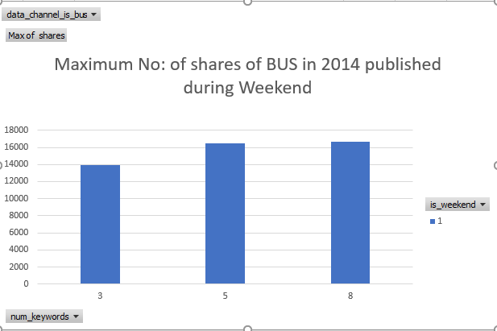
Data Channel – ENTERTAINMENT

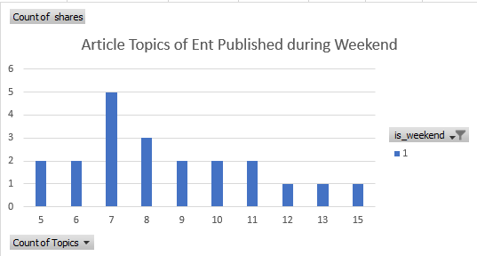
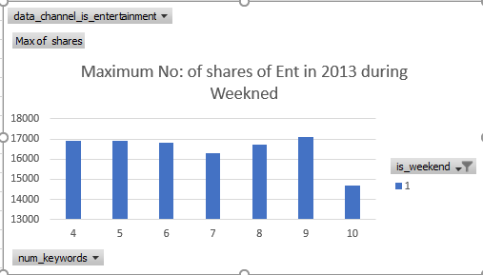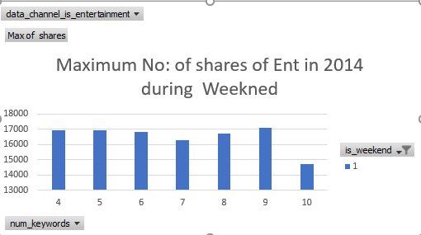

Data Channel- LIFE STYLE

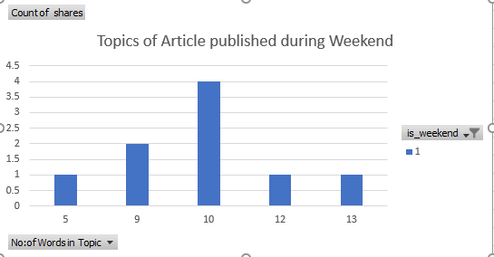
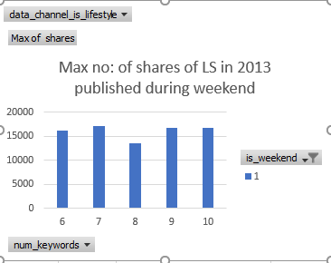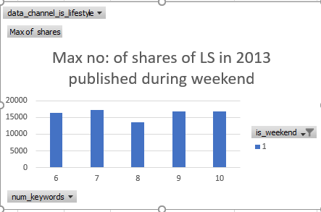

Data Channel – TECH

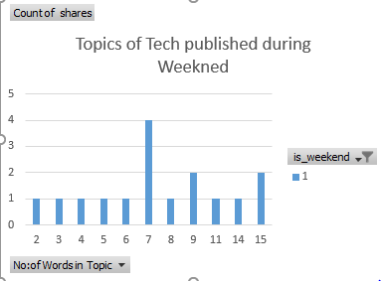

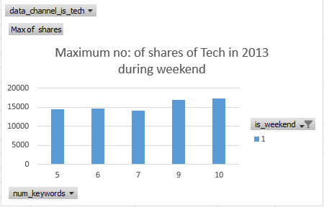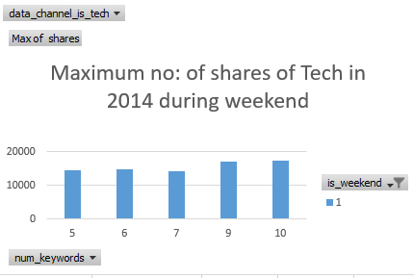
Data Channel – Socmed

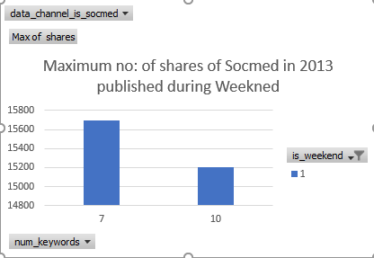

Data Channel – World

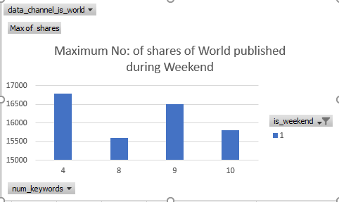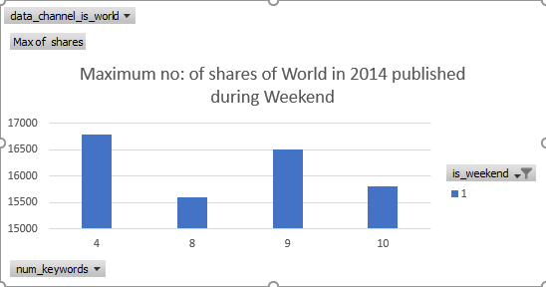

Insights from above graphs:
Statistical measures:
No: of articles 500
Total days (Saturday and Sunday considered) = 2 days
Average = 250
Maximum share - 17700
Minimum share – 13300
- By targeting shares and predicting if the article was in demand on internet or not.
- The max share and min share is different for each data channel. The highest shares were found in 2013 year when compared to 2014 and also in the data channel Socmed there are no articles published in 2014 during weekends.
- Article published on weekend with the topics related to apps, social media and global bias will increase the number the article is shared.
- R^2 is found for each data channel and there are negative to positive results.
- As further analysis was done we need to increase the images, videos and include the worlds which are more popular.
- As when compared older articles are not given high popularity to new articles. This can be overcome by adding an additional reference line in new articles to older articles.
- There are many long words which need to be decreased as to which there is no matching of maximum relation between the different data channels.
- Articles with positive keywords are more popular than the negative.
- There are no missing values, but topics were not classified.
- Data set accuracy:
843300 Shares – Leaked: more low-cost iPhone photo. Least articles where published on weekends when compared with weekdays.
This data set can be improved by publishing articles more on weekdays, need to increase the topic related to technology, business and avoid social media. Publish article close to topic for better purity.
R^2 here is too small. If we try to remove the data channels one by one or any other attributes does not improve our R^2.
(Krishnamurthy, 2016)
SAS Text Miner for keyword analysis:
Text mining basically consists of two phases exploring the textual data for its content and next is by using the discovered data to make better existing process. Both ways are very important as it gives descriptive and predictive mining.
Descriptive involves determining concepts in a textual form and the results helps to give better collection of textual understanding.
Predictive mining helps for decision making which examine the past data for predict result.
Following nodes are used for analysis in text mining. Import, Parsing, Filter, Topic, Cluster, Rule builder nodes.
Tool | Action | Result
Text import | File Pre-processing | Creates a SAS dataset, which is further used as i/p for text parsing node which may contain actual text or path to the actual data.
Text Parsing | Text parsing | The text data decompose and gives quantitative form.
Text Filter | Transformation in which dimension reduction is done | Quantitative form is further resulted to compact and informative format.
Text Cluster, Text Topic, Text Rule Builder | Doc analysis | Whatever data is collected it performs classification and prediction and create clusters, topics from the data.
Source: file:///C:/Users/Laeeqa/Desktop/tmgs.pdf Getting Started with SAS Text Miner 12.1
Following task are performed while setting up the project
- By creating a new project where the complete work is stored.
- Library is created to store the data source.
- By exploring and modifying the online popularity data.
- By creating new diagrams in the project which will be used to interact with the nodes.
New Project – CA Assign 1, Data sources – has been created. When we double click each source, the variables can be changed. In this task we require keywords to be extracted from title, so we have changed title to text and content, topic and URL as Label by keeping all other variables constant.
Many organizations boost their website by search engines to find articles, documents by using keywords. These keywords could be used to analyse the topic and related article. By right click on the text topic and after running, the results are obtained to find key words for the data channel Bus.

1.Keywords from the title
- Data channel Bus
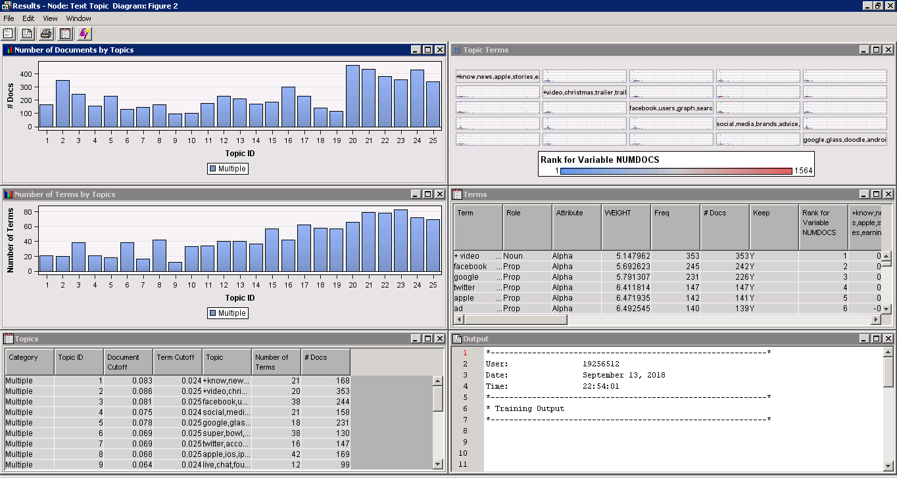
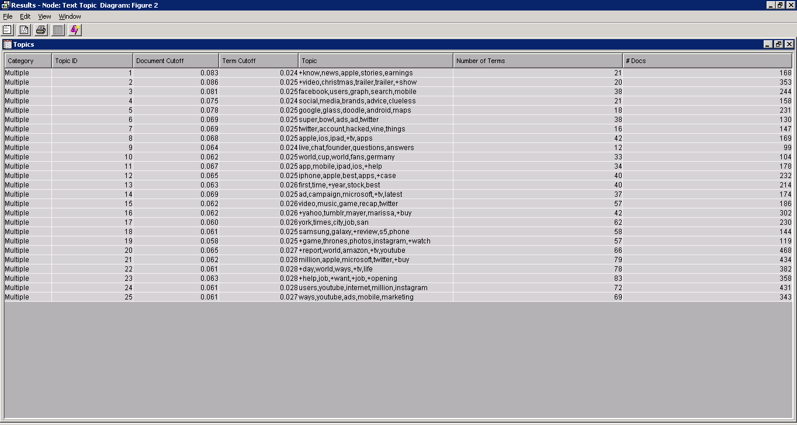
From the above we have observed that after sorting the topic with their Id’s following keywords of topics are seen. The top id’s key words where interpreted related to bus, like a group of entity to produce. The keywords such as youtube videos, marketing business, apple mobile, social media, travel are main keywords for the topic title.
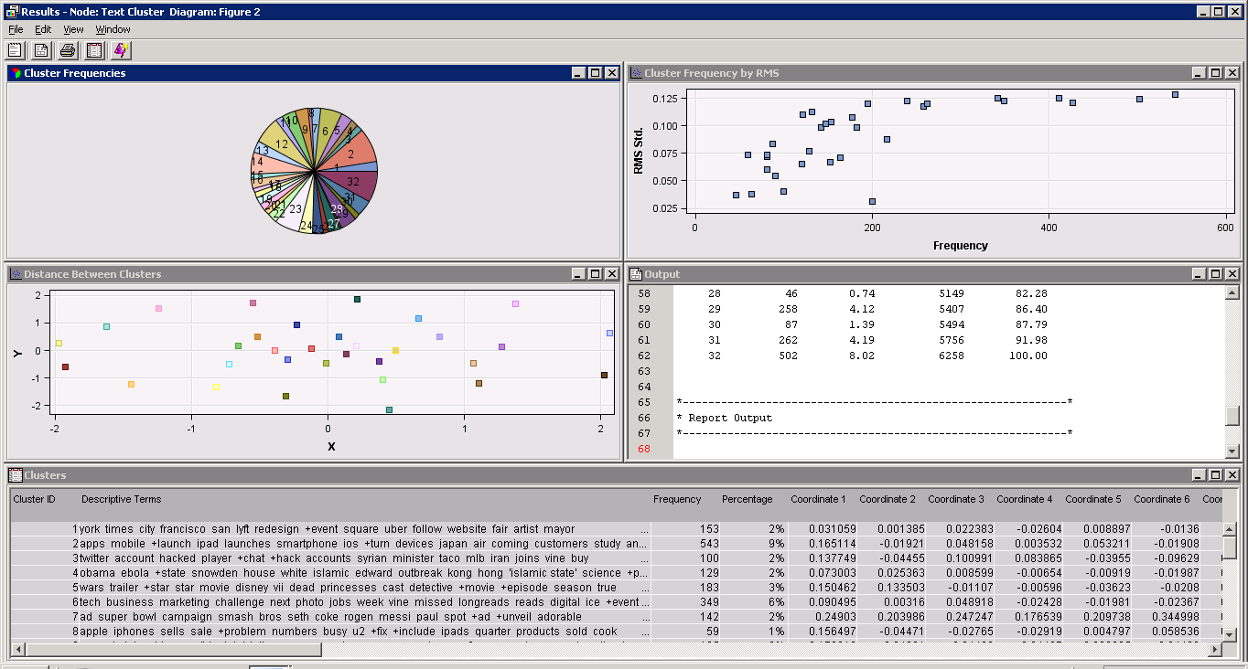
Results were found for text cluster which shows the clusters which are grouped together are highly correlated to each other. As the frequency of the cluster increases the RMS also increases and they are split apart.
The main difference between topics and clusters is that there are multiple text topics but only one text cluster.
Therefore, from the above analysis we can predict that cluster will not give exact keywords as we are looking for. Hence, text topic will be the best method to follow.
The other data channels are places in one figure and for every run their connectivity varies. For example,
Data Channel - Entertainment
From the above we can predict that topics keywords are mainly related to entertainment like watch videos, website, social media, games. The docs here represent number of emails fall under each topic. The maximum emails related to were for videos and followed by internet.
Data Channel- Lifestyle
From the above we can predict that the keywords of title are related to lifestyle- how kids are grown up using top digital apps, love for gadgets, friends, special day celebrations and websites. The maximum documents where related with apple followed by digital life.

Data Channel - Socmed
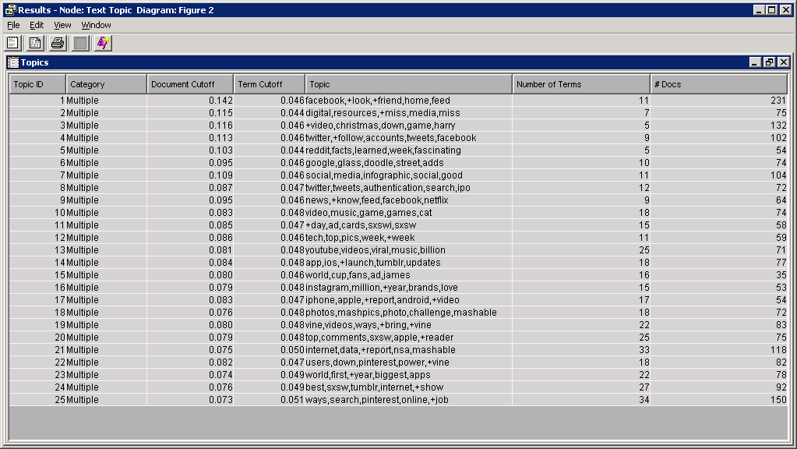

The topics where sorted as per the topic Id and the maximum articles were related to facebook and online job search.

Data Channel-Tech

Data Channel -World
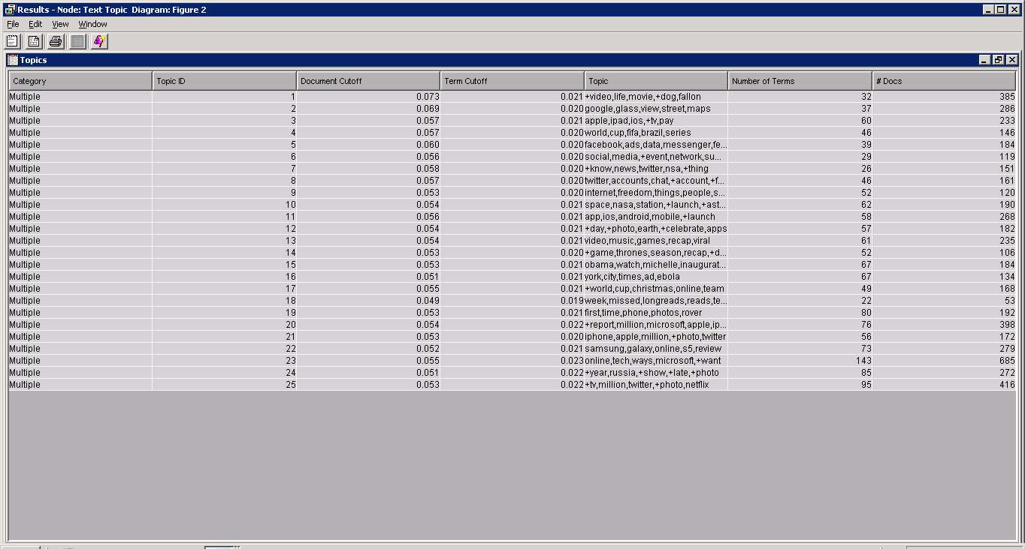

As the data channel is related to world the highest documents where related to Tv, multimedia, videos.

2.Top 10 topics
BUS
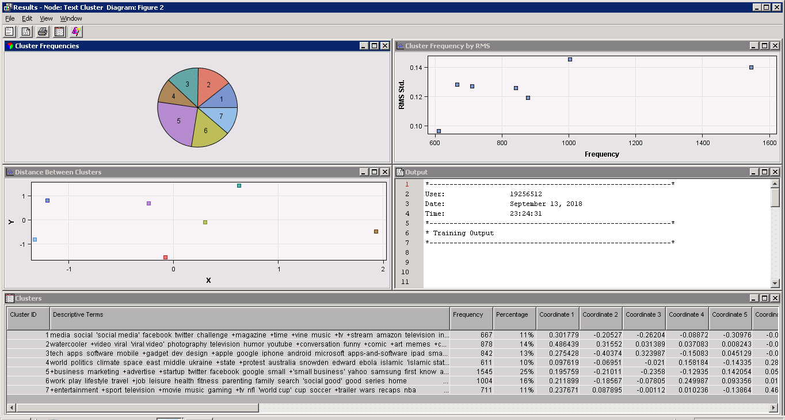

ENT
LIFESTYLE

SOCMED

TECH

WORLD

When the top 10 topics of each data set is observed there are more few topics related and inter connected with each other like video, facebook, google.

3.High shares and Low shares

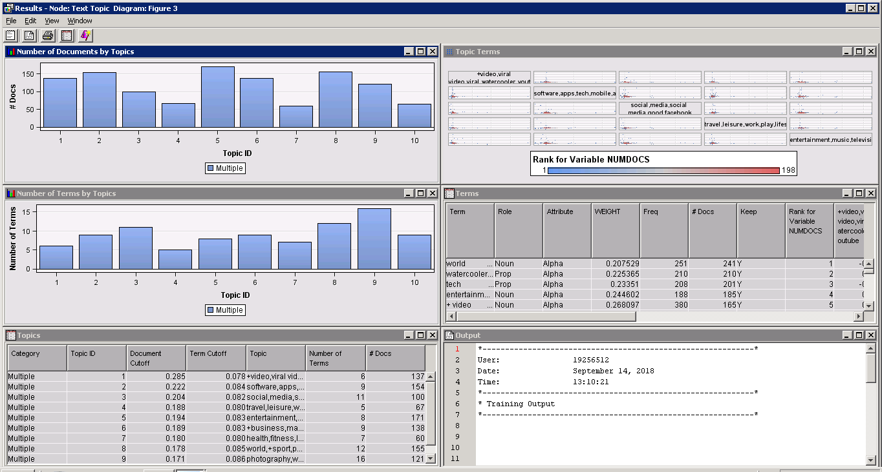

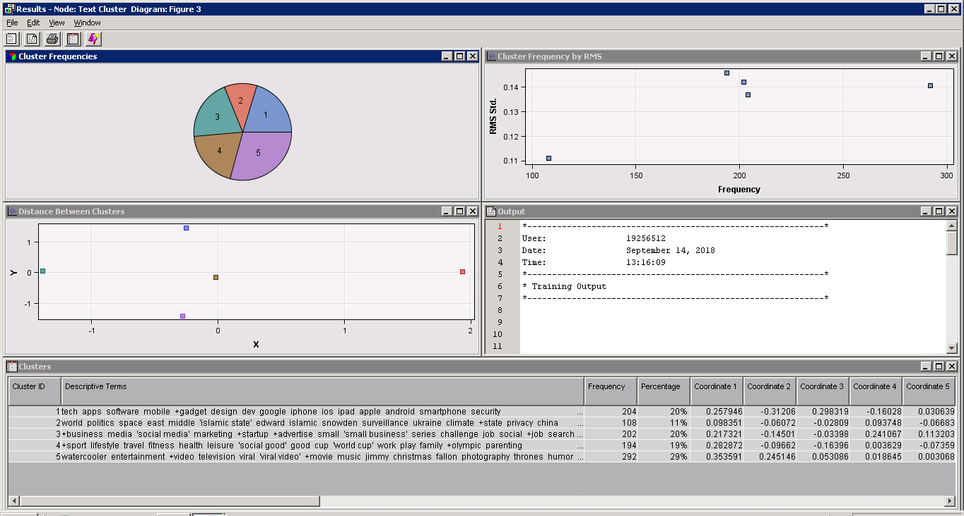

Lowest

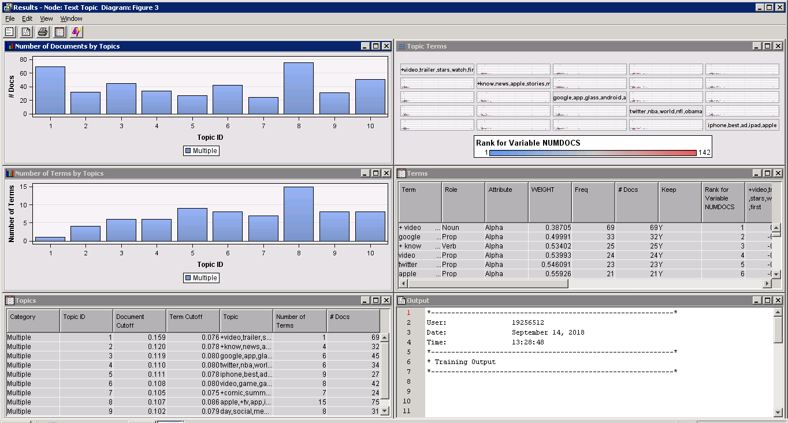

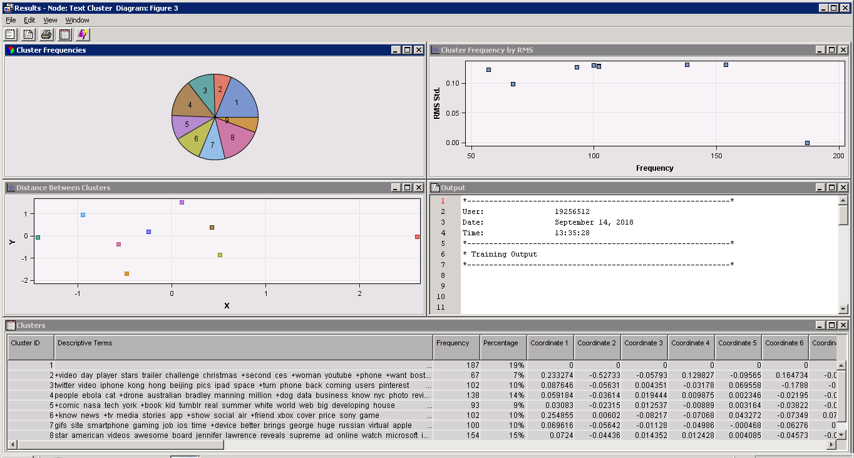

Insights from the above SAS text mining

Predictive modelling using machine learning is gaining more popularity. It extracts numeric data from the text, which helps to make text accessible to data mining. It helps to forecast topic trends in future which would be useful in modelling, forecasting for future trends. To get the meaningful insights analysis was done
- By changing the relative variability as per requirement. For example, in top 10 analysis the topic variable was changed from text to label.
- After every text topic node a run was done and results were collected for each data channel. By default it identifies 25 topics
- Number of document charts where plotted where it gives a relation between the highest topics, documents and terms.
- The topics which are generated above are by running text topic node.
- The articles related to video, social media, gaming, iphone where high and on top list.
- The main concern here is the articles with low documents should also be given importance.
- Each data channel have either iphone or social media as their first topic. So, much care should be taken that the topics are not over written and a frequency should be maintained.
- Analysis on clustering was also done to test and for a unique group each document is assigned. For which, terms and doc can belong to more than one topic or none .
(SAS),
(Saini)

Case Study 2

1.R

We have developed sentiment analysis based on R library. The packages used to build our model are “syuzhet”,”ggplot2” and “RTextTools”. This help to predict the accuracy of various algorithm implemented. Sentiment analysis helps to take decision on certain topics and helps to find positive and negative sentiments.
Syuzhet has four sentiment dictionaries, it helps to quickly extract plot and sentiment data from text files. It has short function and the data can be visualised. We can easy load the data from read.csv()
The bing lexicon helps to differentiate between positive and negative. Ggplot2 gives visualization. Ncr assign words in form of positive, negative, joy, sadness, angry, fear etc and last Afinn assign score that run between negative to positive.
Get_sentiment assess the sentiment of each word or sentence. We use different methods for sentiment extraction. Syuzhet is default method. This package comes with four sentiment dictionaries which are applied in the case study.
The accuracy obtained by syuzhet – 0.74,by bing – 0.76, by afinn- 0.76, by ncr -0.68
- Plot :
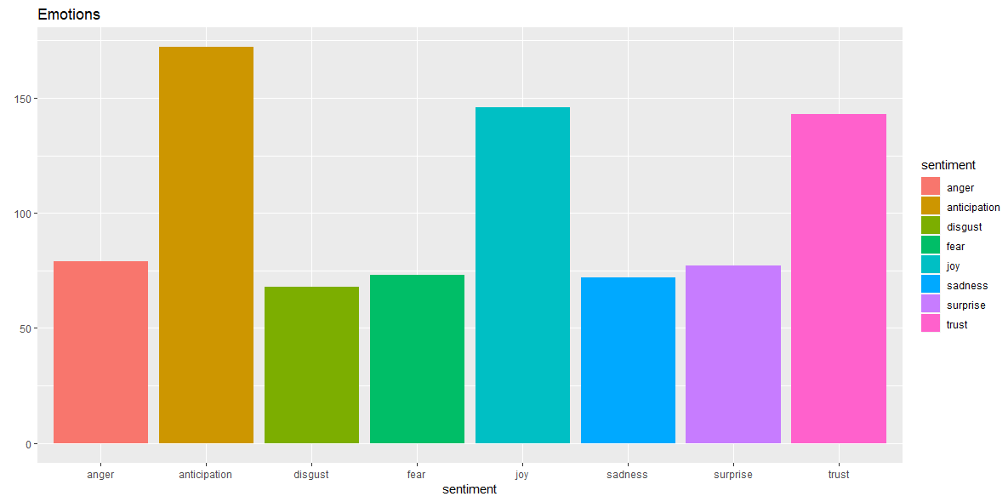
From the above plot we can analyse that anticipation is the highest followed by trust and the least is disgust emotion. Here anticipation is sentiment.
(Liske, 2018)

2.Sentiment Analysis SAS
Sentiment analysis classify emotion mining, opinion mining, subjectivity and analysis. It helps the organization understand what their customer wants their attitudes and opinions.
The model can be constructed either by simple or by advance method. The percentage of training document should be given for validation purpose. The validation based on corpora, advance statistical model is built. There are four combination of models text normalization, smooth relative frequency combined with no feature ranking, chi-square and risk ratio.
By taking term frequency model is built from training document. The statistical model gives sentiment for overall document not on feature based. Probability of cut of is set till 60% from which best Bayes model is selected.
60% - Training and validating
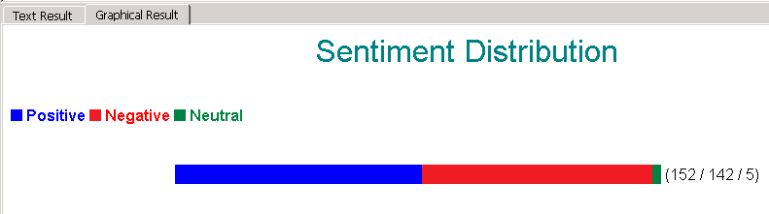

Testing
60%
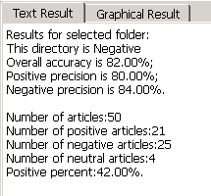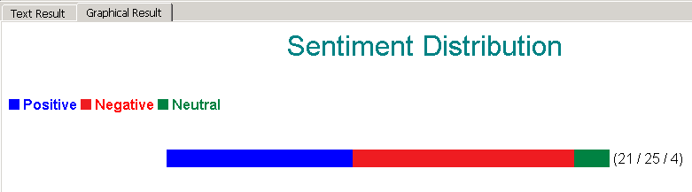

Test for the statistical model:
Scored documents – which are correctly predicted positive and negative.
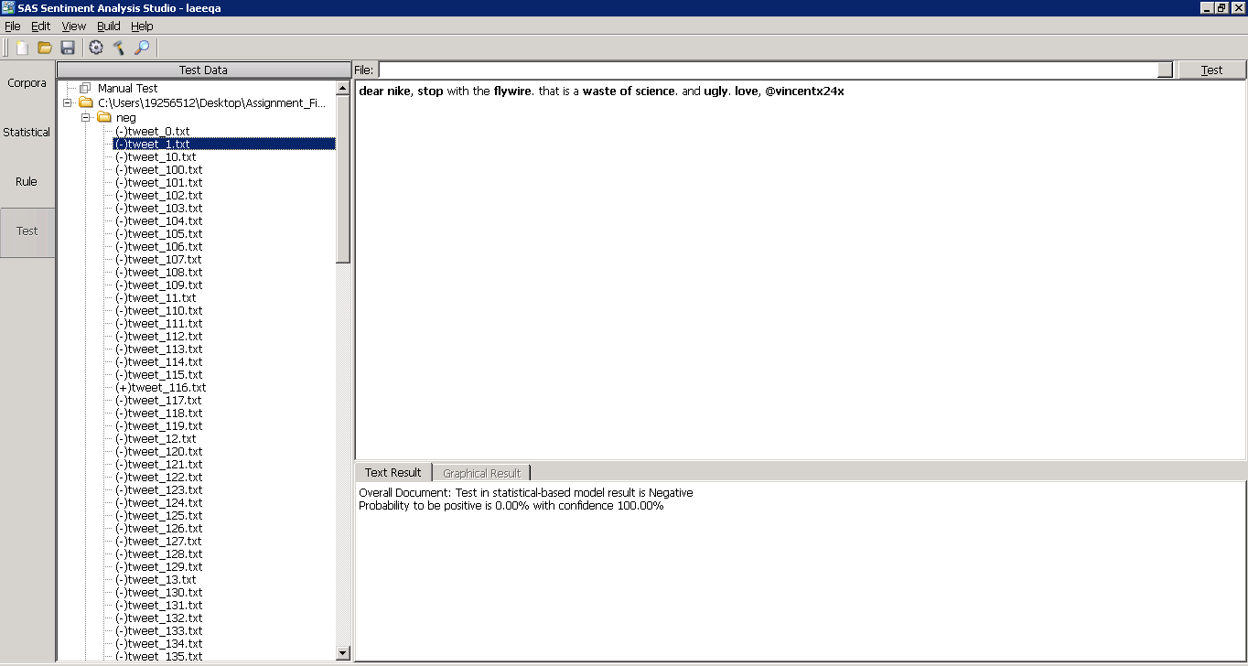
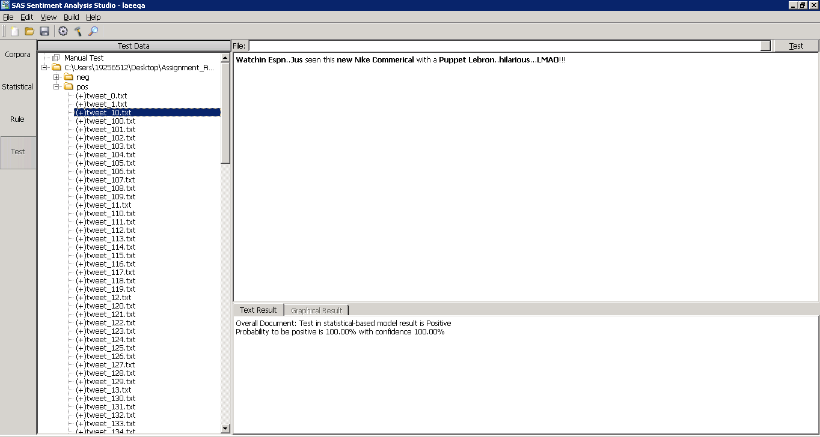

Same procedure was carried out for testing: 40%
Statistical results:
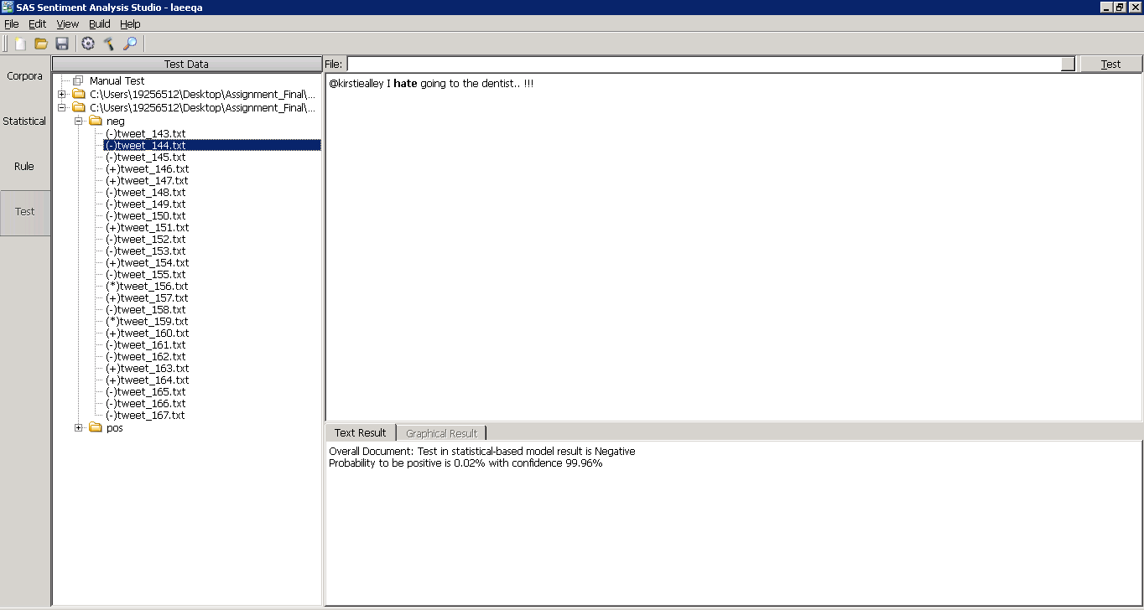
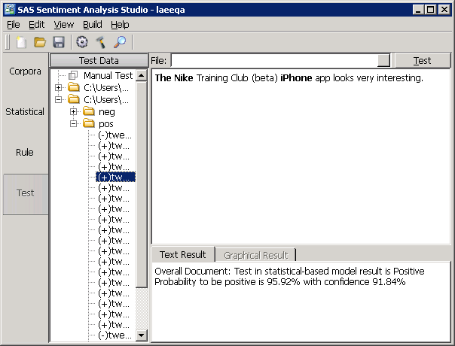
(Dr.Wei, 2018)

References
Dr.Wei. (2018). Customer Analytics and Social Media. Retrieved from https://lms.latrobe.edu.au/course/view.php?id=55106
Krishnamurthy, P. S. (2016, 17 Dec). Web analytics. Retrieved from https://www.slideshare.net/AnkurVora4/online-news-popularity-analysis?next_slideshow=1
Liske, D. (2018, March 29). DataCamp. Retrieved from https://www.datacamp.com/community/tutorials/sentiment-analysis-R
Saini, A. (n.d.). Mashable.com - A Process to Predict Online News Popularity. Retrieved from http://inseaddataanalytics.github.io/INSEADAnalytics/groupprojects/January2017/MashableNews.html
SAS. (n.d.). Getting Started with SAS(R) Text Miner 12. Retrieved from http://support.sas.com/documentation/cdl/en/tmgs/65668/HTML/default/viewer.htm#p0h3ucz6ysgi7wn1a0s8jft44ayx.htm

